Appending an Object
12/21/2026
Open the file that you want to bring the object into. File- Append
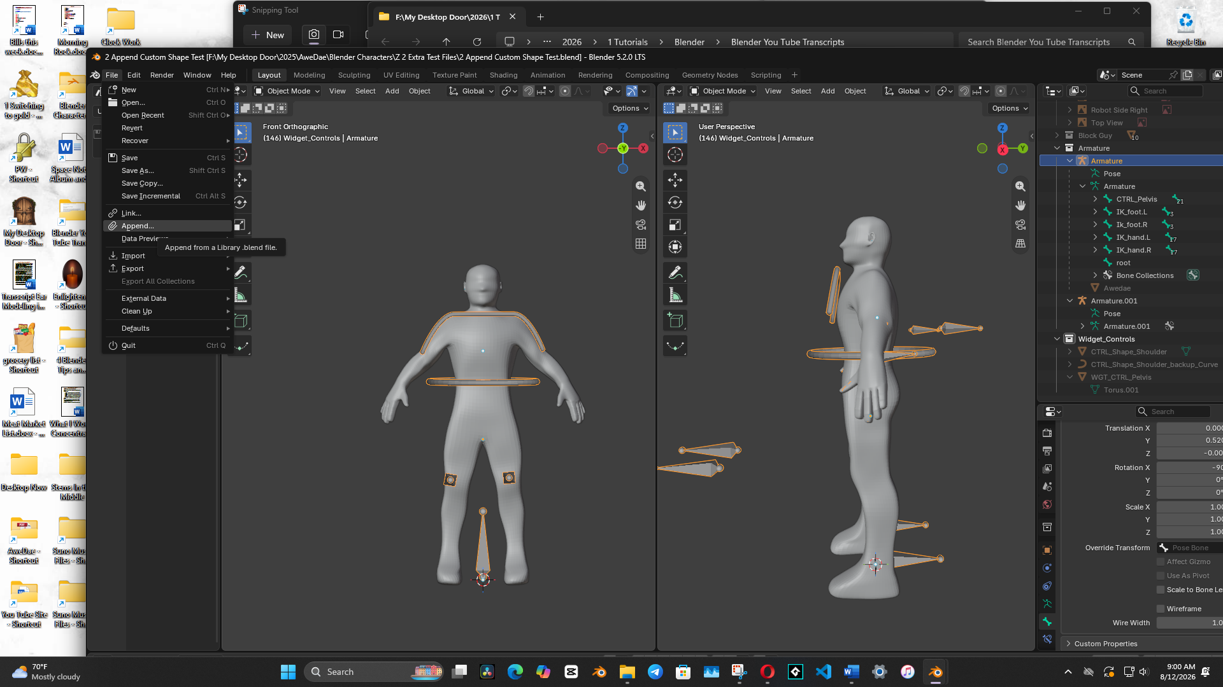
Browse to the File you want to use to append the object. Double Click to go inside it.
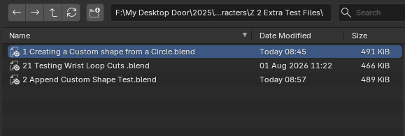
Choose the Object folder.
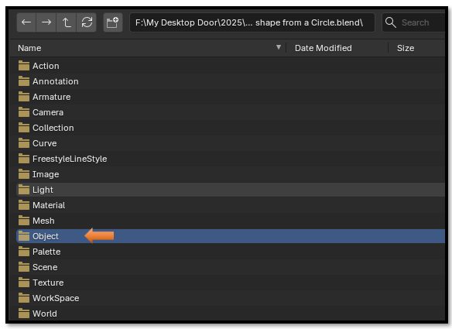
Go inside to Append the object that you want to append.
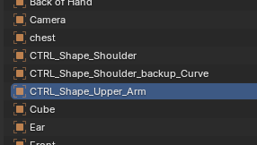
Hit the Append button at the bottom
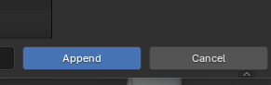
And the Append worked perfectly, even positioning the object correctly inside of the new scene.
